5th Grade Newsletter
For the week of Monday, May 13th- May 17th, 2013
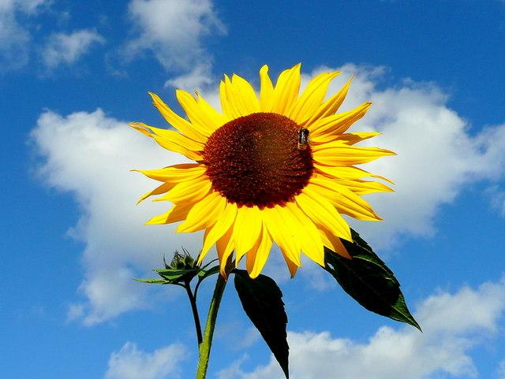 Warm Weather...FINALLY!!!

In Reading…  We are back to our normal schedule after a wonderful experience at Krannert Art Museum! This week, we will be assessing the student’s final reading progress with the DRA. The kids will also finish their Bloom Balls for Chasing Vermeer and present their finished product to the class.  **Make sure that your student is reading for at least 20 minutes every night and that you are signing their Reading Log. The middle school administrators STRESSED how important it is to read, read, read over the summer to be successful in middle school :) ** | In Math…  We have been working on our unit in area and volume. Students have been learning about the differences between 2 dimensional and 3 dimensional shapes in math and how to calculate the areas or volumes of these shapes. Students are also thinking through what surface area is and how to best calculate the surface area of a 3D shape. More of this to come.
Important Dates & Events  Early Dismissal - Thursday, May 23rd @ 11 am  Ms. Crossetti’s Wax Museum - Wednesday, May 29th @ 9:45 am  5th Grade Promotion Celebration - Thursday, May 30th @ 12:30 pm in the classroom  PBIS Field Day - Friday, May 31st 8-10:30 am | Announcements  END OF THE YEAR PROMOTION  We are going to have a small celebration in each classroom. We will be providing refreshments for students only. Parents are welcome to attend. The date is May 30th at 12:30pm.
In Social Studies…  We are learning about the Civil Rights Movement. The students are learning about all the different contributions that were made by many different people. The kids have also selected a CR leader to research and write a speech about. | In Writing…  The kids will learn how to write a speech. We will begin by writing interesting introductory paragraphs. The kids will learn how to “hook” their listener in and set up the structure for what is to be expected in the rest of the speech. The students will also learn how to write events in chronological order.
Contact Information  Stratton: 217-373-7330  Anne Crossetti: crossean@champaignschools.org  crossetti.yolasite.com (class website)  Amos Lee: leeam@champaignschools.org | In Science...  The students will continue to observe the growth and life cycle of the Fast Plants they are growing. We will examine how plants reproduce and talk about different products that are made from plants. We will end the unit this week with a vocabulary quiz on all the new “botany” words we have learned.

