5th Grade Newsletter
For the week of Monday, April 22nd- April 25th, 2013
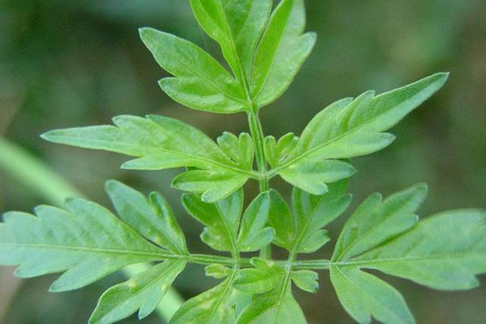 Happy Spring!!!!

In Reading…  We will finish reading Chasing Vermeer by Blue Balliet. This week, we will focus on final discussions about the book. We will do a final project where the students become FBI agents and develop a plan to investigate the art thief. They will write their plan and a letter to the public about the apprehension of the theif. We will also create and finish a Bloom Ball showing our comprehension of the entire nove. This book is in preparation of our upcoming week at the Krannert Art Museum.  **Please ask your child questions when you read with them. This helps students with comprehension and gives them a self-check to ensure that they are thinking about what they are reading. | In Math…  We have been working on geometry thinking about and working with shapes and angles. Students are using their deductive reasoning skills to think about how angles relate to one another. For example if one angle is 80 degrees what is the other angle degree? Now we know that a straight line has 180 degrees, which means the missing angle would have to be 100. Thinking about, talking about, working it out in their mind, and making sense of the problem is all crucial to working with shapes and angles.  Please ask your child what they learned about shapes and angles from class? Just talking about it will help them increase their understanding.
Important Dates & Events  WILL Media Lesson - Tuesday, April 23rd  MTD Presentation - Thursday, April 25th @ 9am  No School - Friday, April 26 th  Krannert Art Museum Field Trip - Monday, April 29th through Friday, May 3rd. 8:45 am - 1:30 pm  PBIS Assembly - Friday, May 3rd @ 8am  5th Grade Promotion Celebration - Thursday, May 30th @ 12:30 pm in the classroom | Announcements  END OF THE YEAR PROMOTION  We are going to have a small celebration in each classroom. We will be providing refreshments for students only. Parents are welcome to attend. The date is May 30th at 12:30pm.
In Science…  We will begin our Unit on Botany. The kids will set up a Botany notebook where they will keep notes on the development of the Fast Plants we take care of during this unit. The kids will also learn the basic parts of a plant and it’s life cycle. | In Writing…  We will wrap up our Poetry unit. The kids will choose 1 poem from each of the 10 forms we learned about. THey will self & peer edit this poem and then type it. After they have typed their final drafts of each poem, we will print them and form a Poetry Collection for the kids to share with each other. Each student will have a day that they will share their very own Poetry Collection.
Contact Information  Stratton: 217-373-7330  Anne Crossetti: crossean@champaignschools.org  crossetti.yolasite.com (class website)  Amos Lee: leeam@champaignschools.org | **MicroSociety Info**  Students showed off their excellence as the Department of Education made their visit to our MicroSociety. They had nothing but positives to say about the program. We are very thankful to our supportive parents and our community partners. We are constantly pushing forward to present meaningful opportunities for our students where they can learn more about themselves as leaders, how to work with others in a formal setting, and grow in their own abilities and talents.

